**Working with rows and columns**

**Introduction**

You may be familiar with adding and formatting content within worksheets. However, up to now, much of the focus of this course has been on working with cells and blocks of cells rather than the worksheet itself. In this reading, you’ll learn about Microsoft Excel worksheets from a broader perspective by exploring techniques you can use to organize your worksheets efficiently.

By the end of this reading, you’ll be able to:

* Manage the rows and columns in a spreadsheet.
* View, insert, duplicate, and delete worksheets.

**Worksheets Overview**

An Excel file is called a workbook. The workbook can be composed of one or more worksheets. The worksheets, normally referred to as sheets, are all part of the same file. You can add and remove sheets to organize your data within the workbook. For example, Adventure Works might have all the information on a client contained in a single workbook. This workbook could contain separate worksheets. You might decide to put different categories of information on each sheet, such as order history or sales amounts. Or you might put data from different countries on different sheets.

A worksheet can hold a large amount of data. One worksheet can extend to over sixteen thousand columns and over a million rows. This capacity is helpful when working with large datasets. However, it also requires effective use of formatting so that a worksheet’s users can find the information they need.

Let’s demonstrate how this works by reviewing techniques Adventure Works can use to organize workbooks and worksheets to make it easier to find information.

**Working with rows and columns**

**Resizing Columns**

Data may not display, or it may display differently, when a column is too narrow. Or text may not display fully. This does not happen with numbers because hiding digits could cause readers to misinterpret a value. If a long number is inserted into a column, then the column adjusts automatically.

However, if the width of the column has been set manually, this resizing does not happen. Instead, Excel changes the display to indicate there’s an issue.

In the screenshot, one cell in column **E** has a numeric entry, but it displays in scientific notation. The number entered in the cell in column **E** is 125319. However, the display is 1E+09. The other cell in column **F** has a repeating hash symbol when its content is actually 125. Both display formats indicate that the columns must be widened to ensure that the numbers in cells **E1** and **F1** are fully displayed.

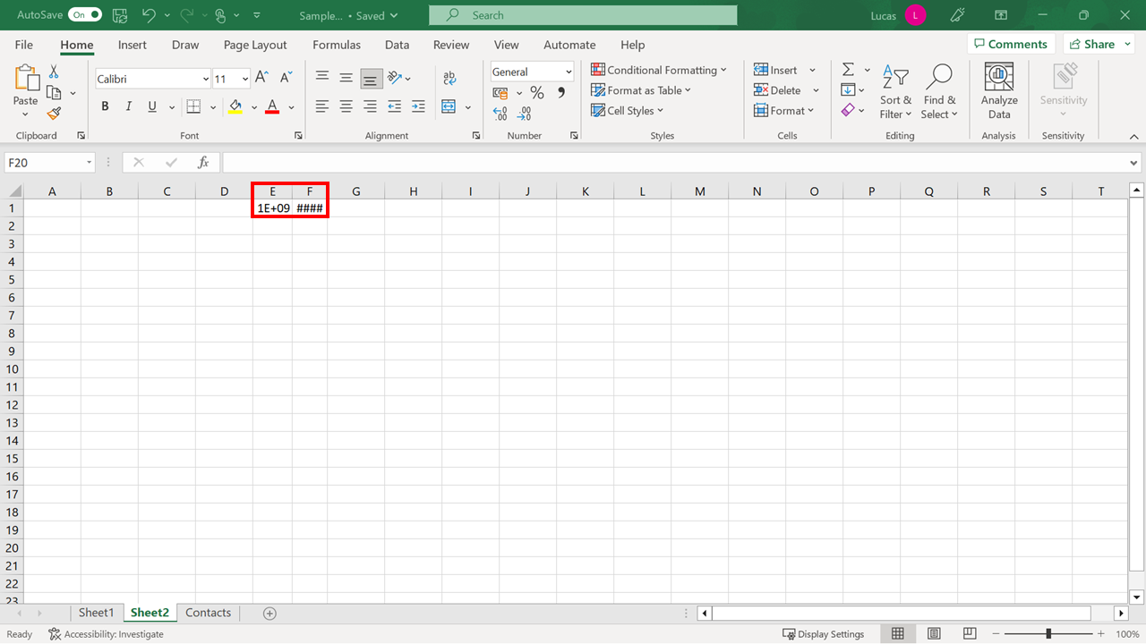

To change the width of a column, you can place your mouse pointer on the vertical line between the columns (where the column letters are). Your cursor turns into a vertical line with a small arrow on either side.

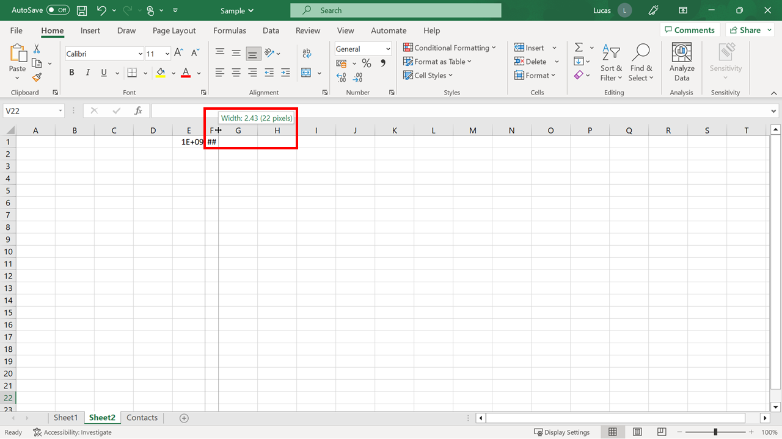

When this pointer displays, select the left mouse button to drag the column edge to the left or right. As you drag, the column size is displayed in a pop-up label. In our example, the width is currently 22 pixels. The size of the column is changed when you release your mouse.

To change the depth of a row, place your mouse pointer on the dividing line that displays between two rows. Then select and drag up or down to make the row larger or smaller. As you drag, the row size is displayed in a pop-up label.

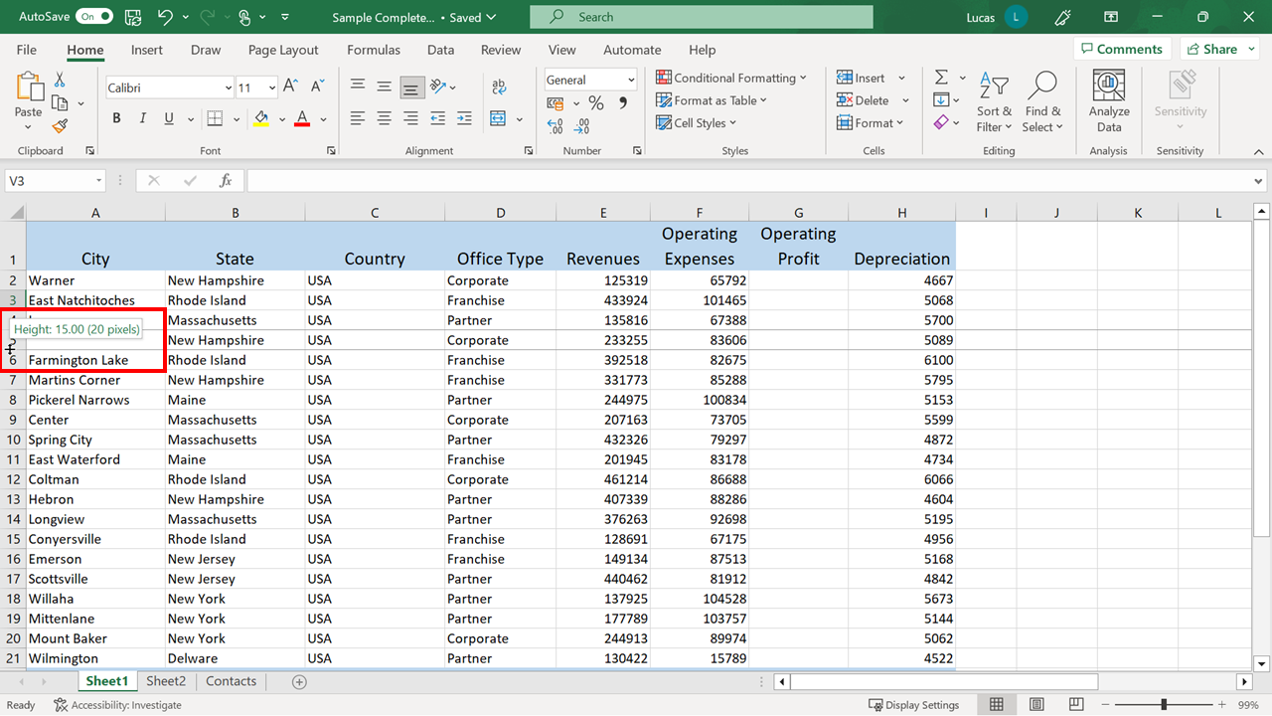

There’s also a shortcut available to complete this task. Double-click the vertical or horizontal separator lineto resize a column or row to fit its contents automatically.

**Inserting and deleting columns**

To insert a new column, select the column to the right of where you want the new column to appear on the worksheet. Or, to add a new row, select the row below where you want the new row to appear. Then on the **Home** tab, in the **Cells** group, select **Insert** and choose what to add.

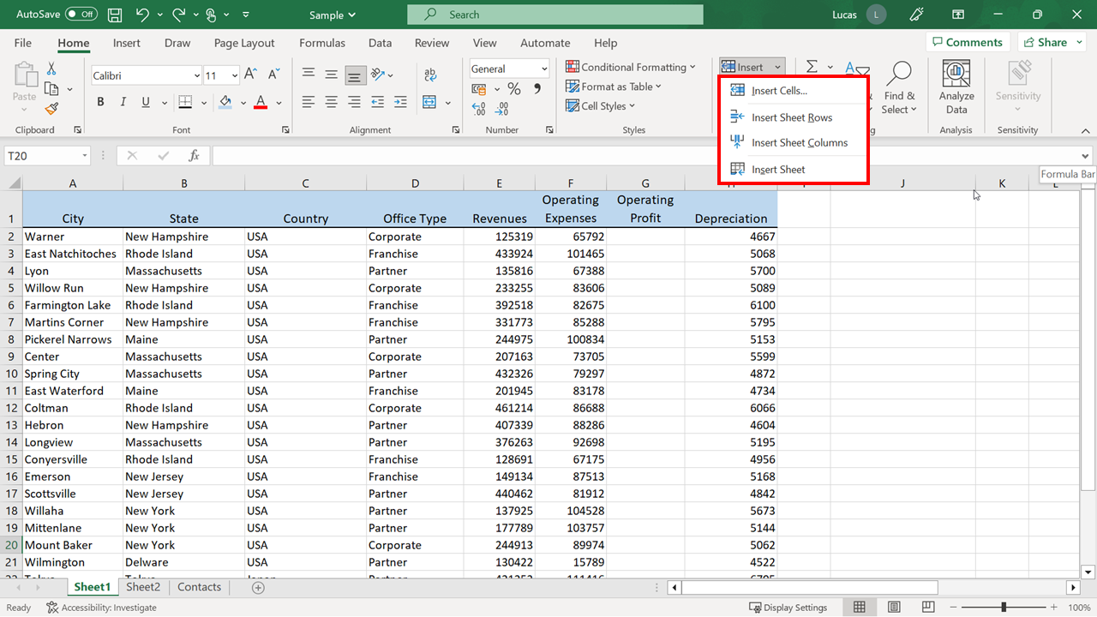

You’ll also find the **Insert** option on the right-click menu. To open this menu, right-click on a cell in the worksheet. After selecting the **Insert** option, it opens a dialog box that contains an entire columnchoice.

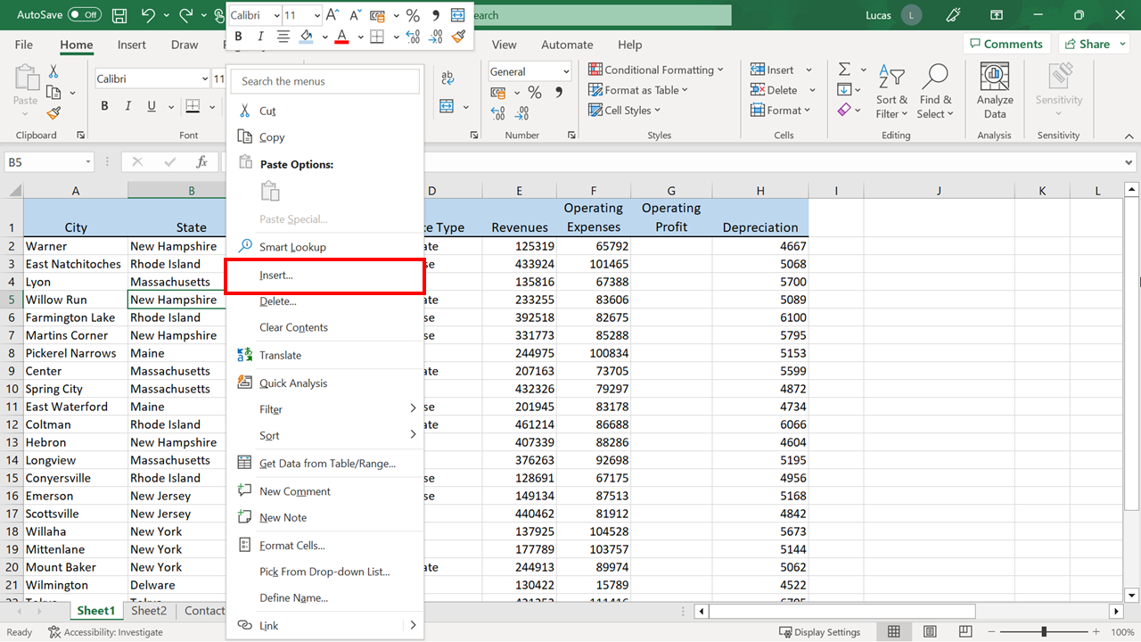

Deleting rows and columns works similarly. These commands are also available in the **Cells** group on the right of the **Home** tab and in the right-click menu.

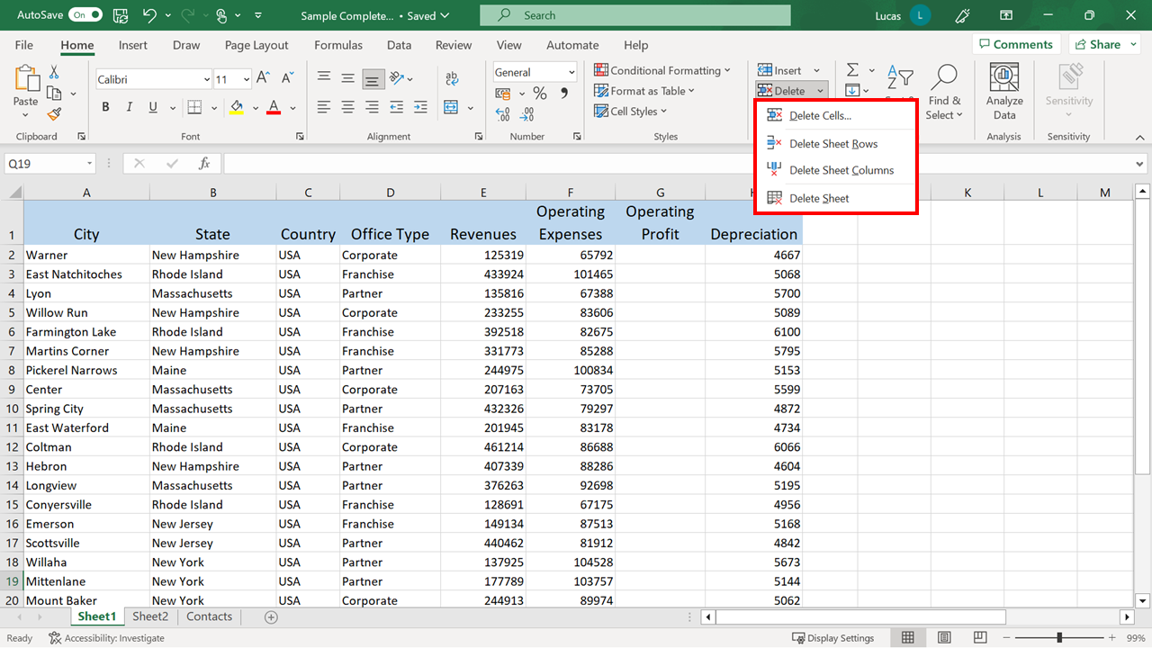

**The Hide and Unhide Options**

With large spreadsheets, hiding columns or rows when they’re not required can be helpful. First, select the columns or rows to hide. Then on the **Home** tab, in the **Cells** group, select the **Format** drop-down button. Next, select the **Hide & Unhide** option. Finally, choose the desired option.

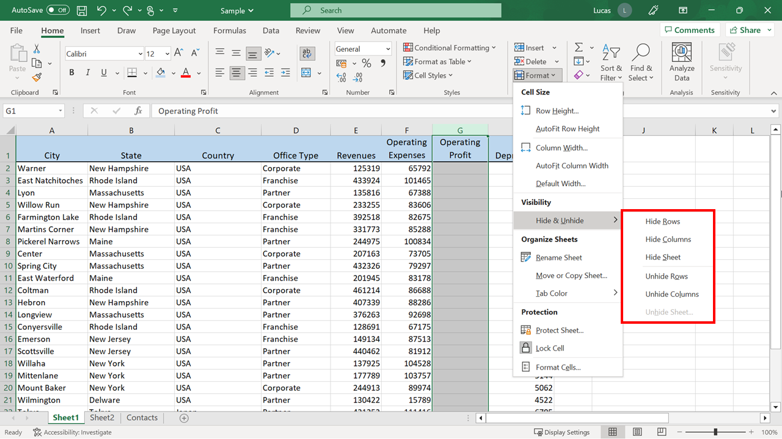

In the screenshot, column **G** is hidden. The alphabet letters on the column headers confirm this as they move from **F** to **H** with no letter **G** in between.

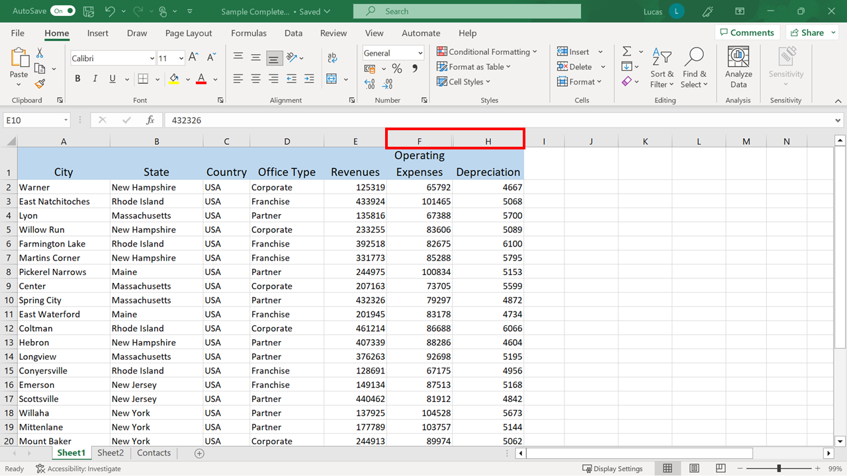

To unhide a column, you must first select the surrounding columns. In this example, that requires selecting **F** and **H** to unhide **G**. Then repeat similar steps to hide the column on the **Home** tab. Select **Format**, and then from the **Cells** group, select **Hide & Unhide.** Finally, select the **Unhide Columns** option.

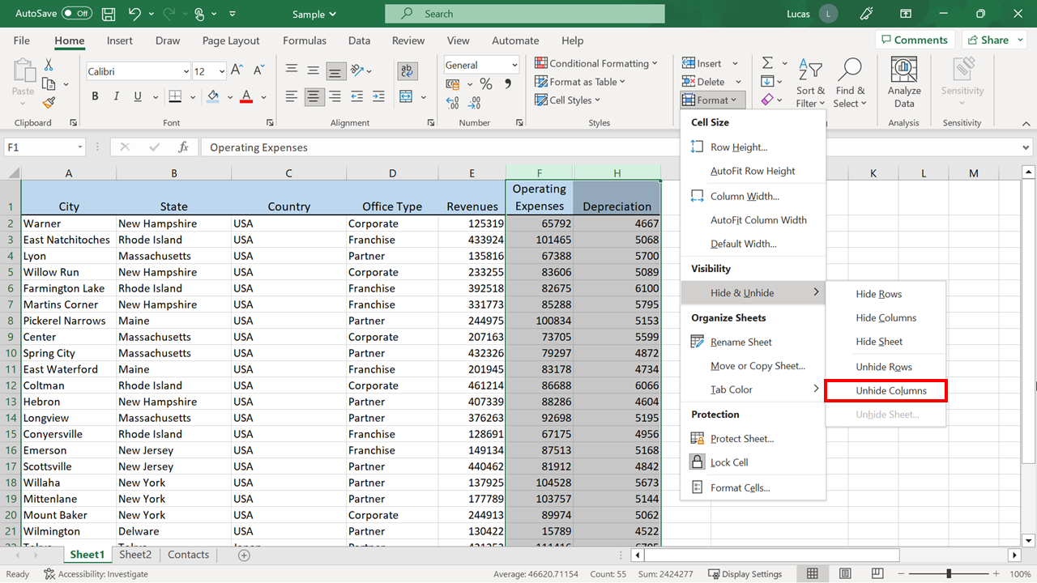

**Conclusion**

In this reading, you reviewed a range of techniques that can be used to create organized workbooks and worksheets. You should now know how to use these techniques to find information quickly and organize content efficiently on your worksheets.